| **Parklands High School** |
| --- |

| **Teacher of Drama** |
| --- |

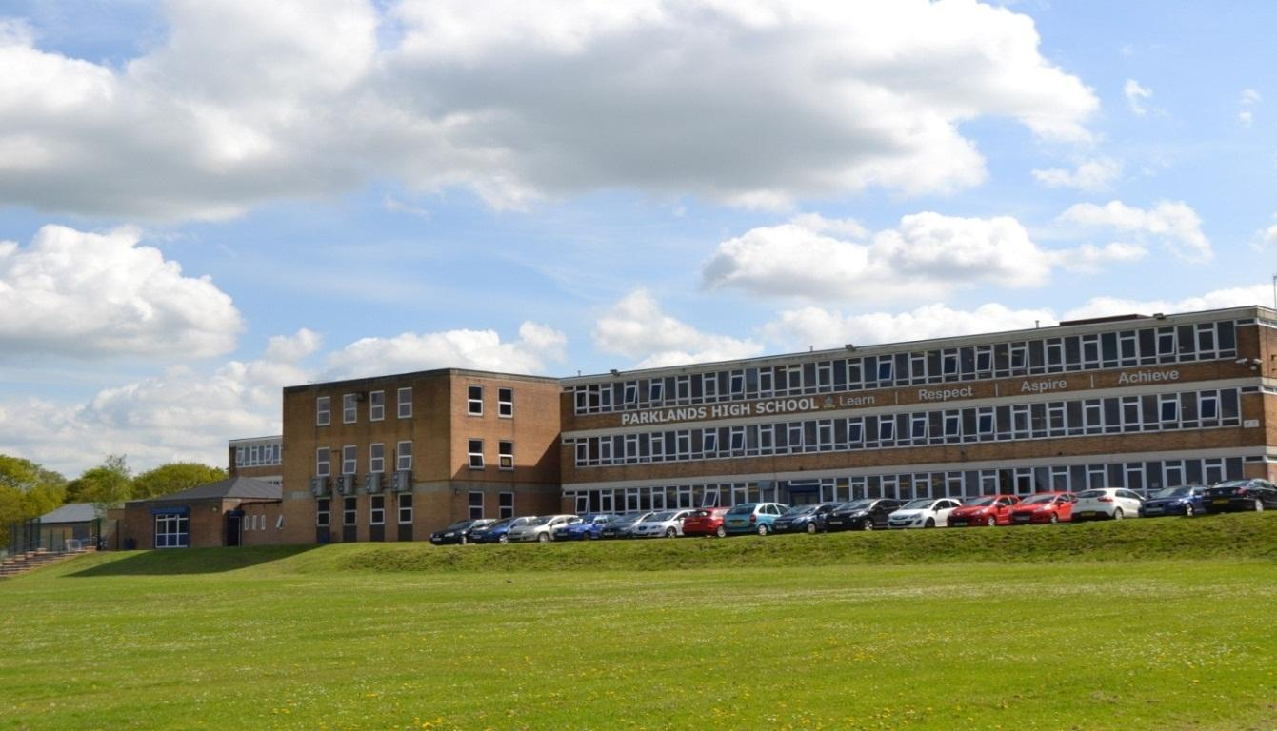

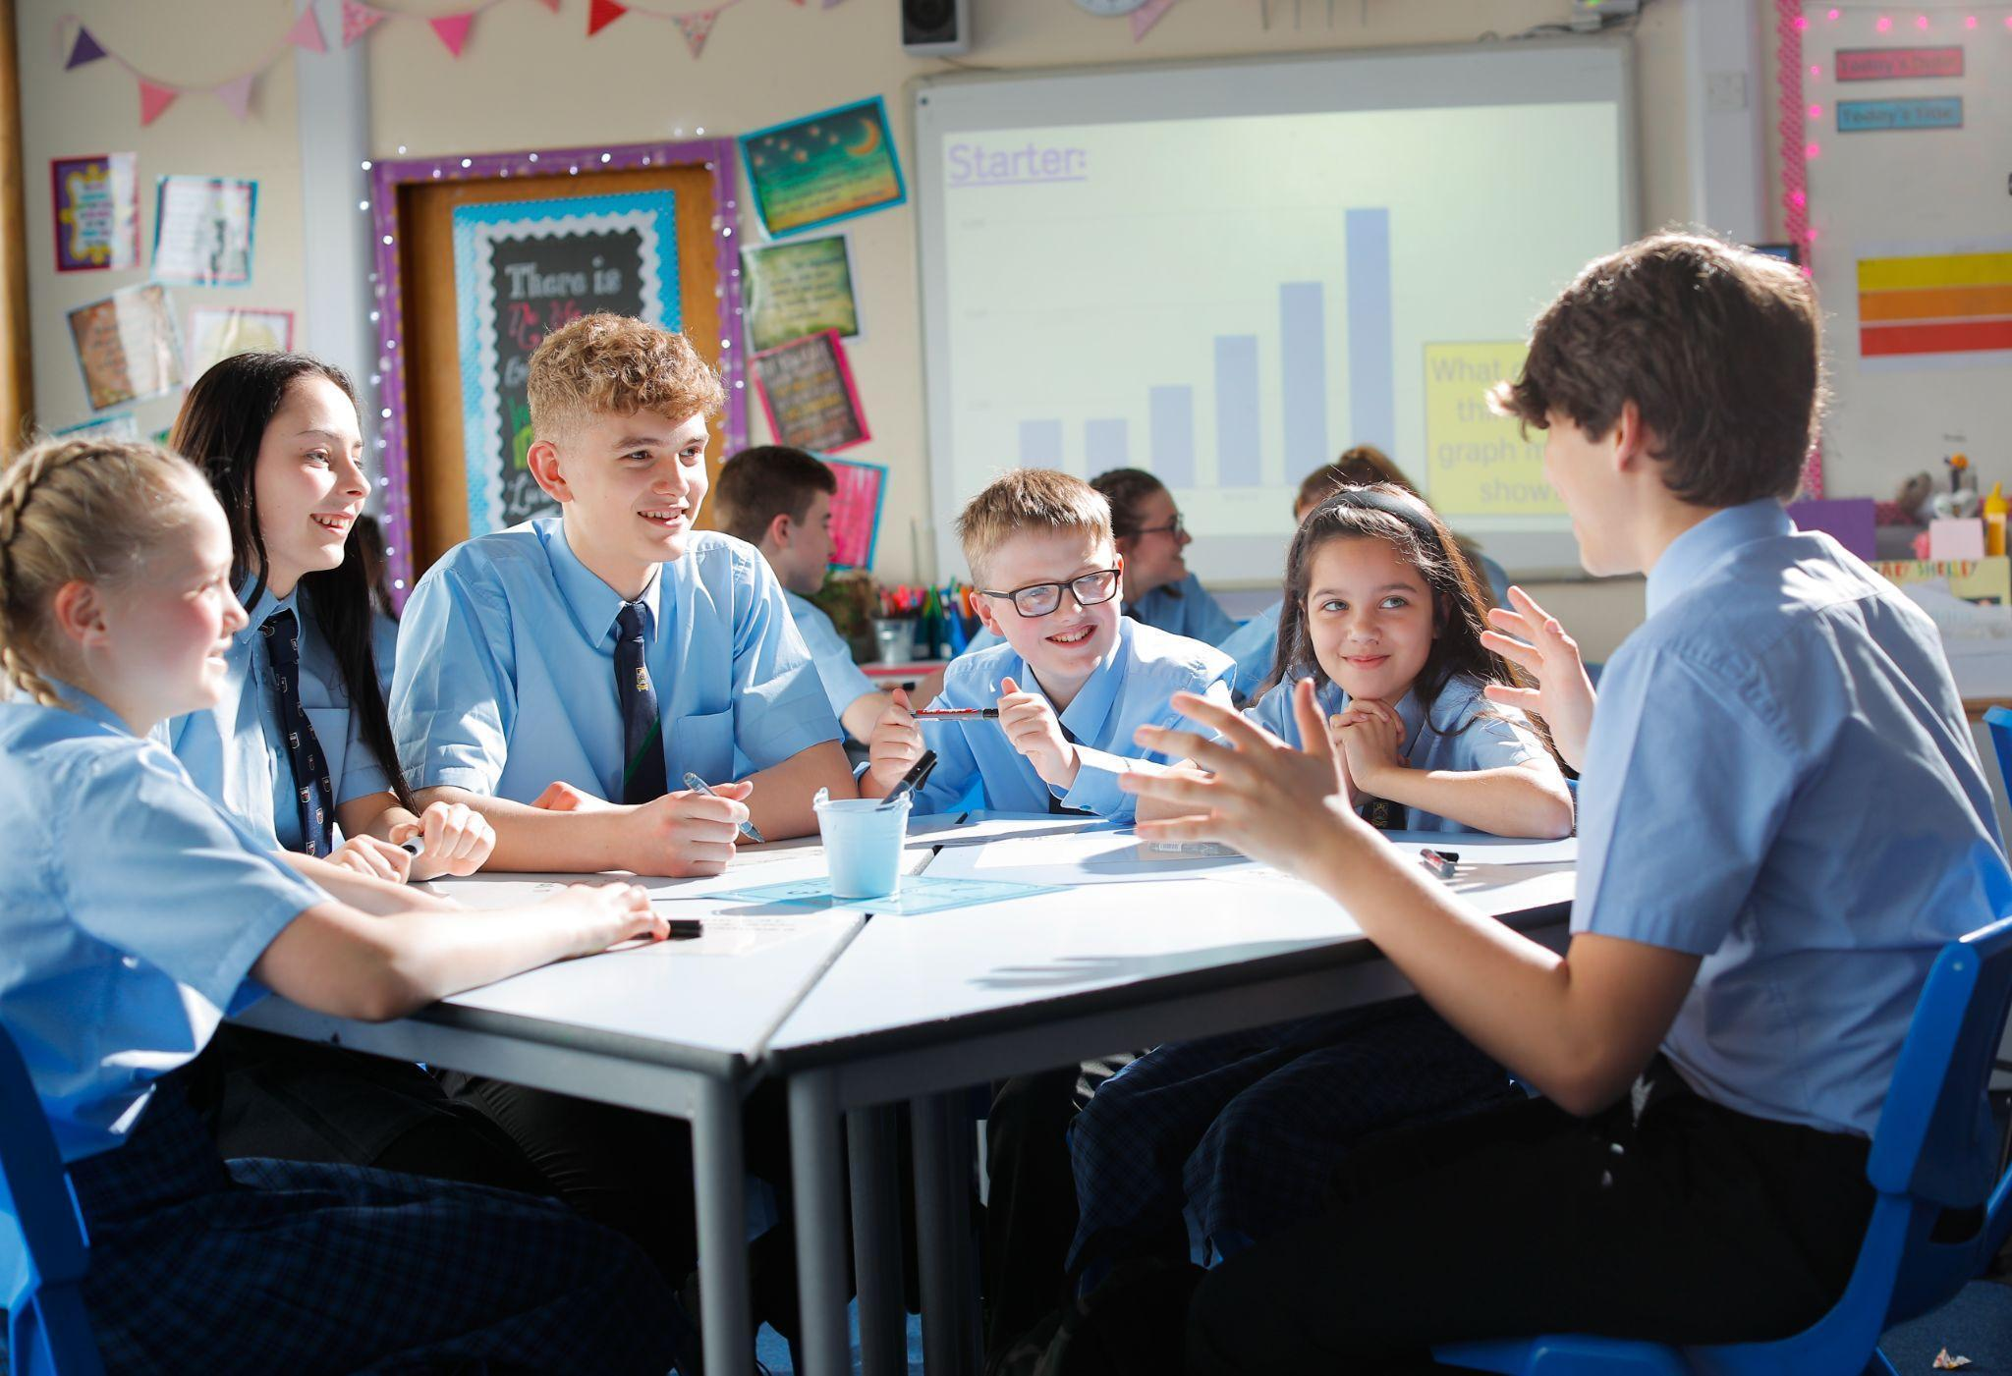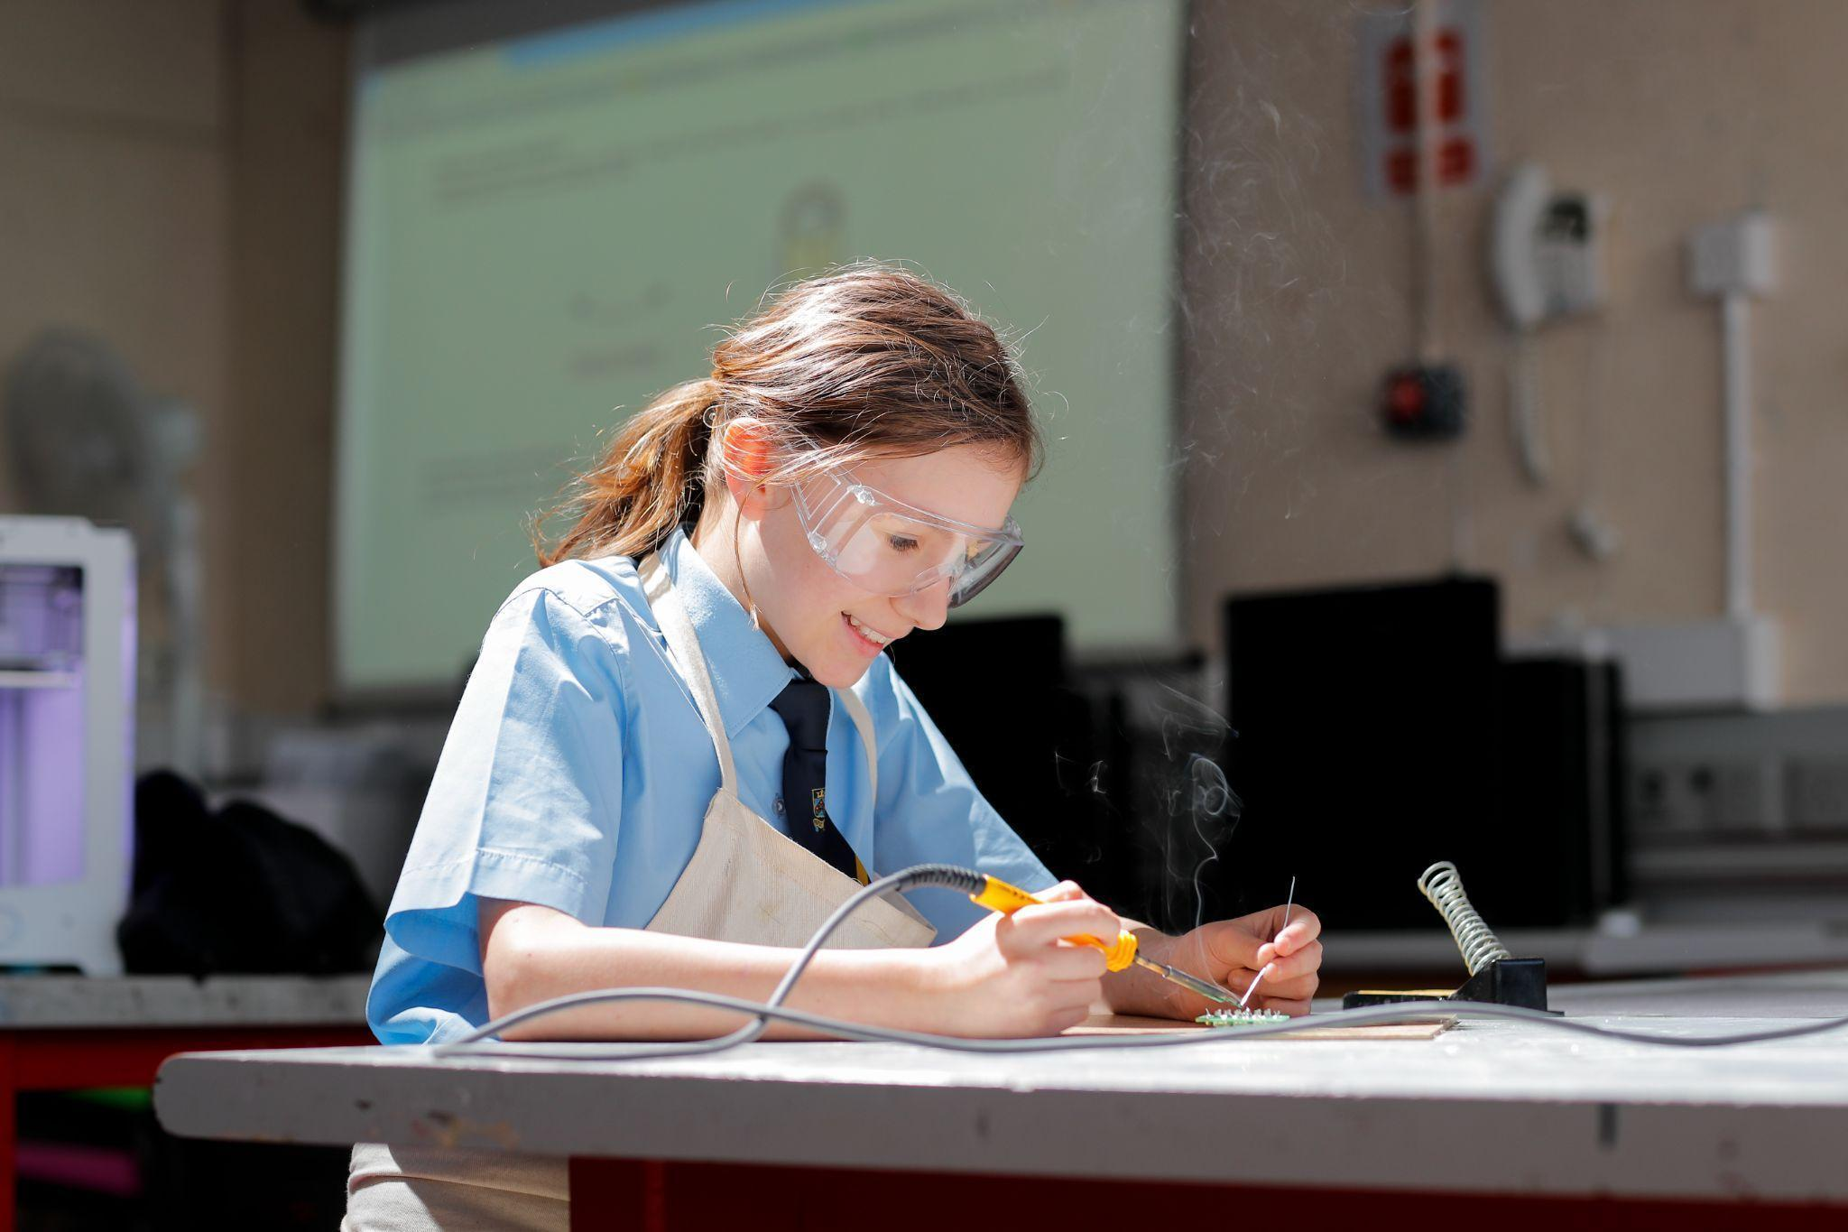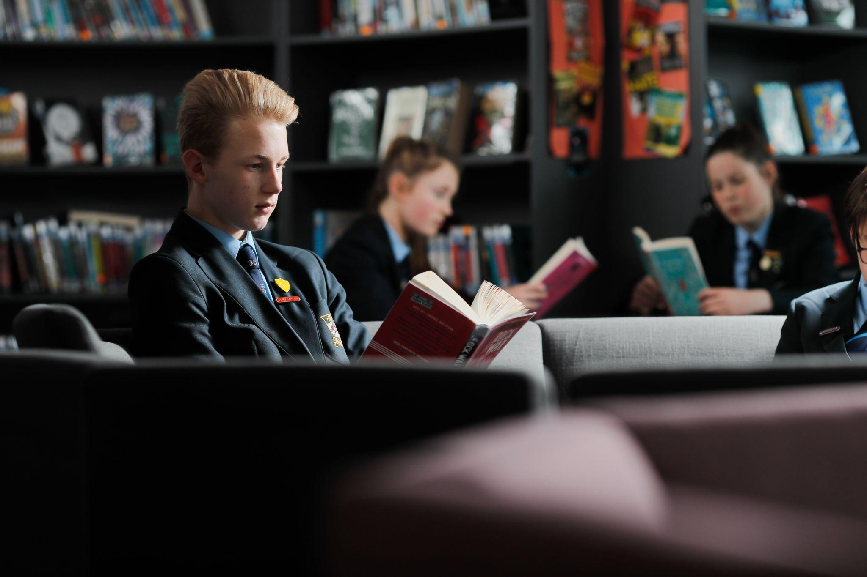

Sept 2025 

Dear candidate,

May I take this opportunity to introduce you to Parklands High School, an oversubscribed, successful, supportive and high achieving academy with 1140 students on roll.

Our joint vision is to:

* Advance education by providing a holistic, all-through education to ensure our learners are well-prepared and ready to meet the challenges of the next stage in their education, training or employment.
* Instill the character traits necessary to ensure all our learners can successfully contribute to a global society by focusing on an evidence-based approach to Character Education and Personal Development from Reception through to Year 11.
* Offer rich and varied opportunities to promote spiritual, moral, cultural, and social development, from primary through to secondary.
* Aim to ensure no child, regardless of their educational needs or background, is left behind due to our inclusive approach.
* Ensure our learners can contribute economically to the local and surrounding communities through our deep understanding of careers and economic education and the local, regional, and national labour markets.

Parklands plays an active role in teacher training and in collaborating with other schools. It is also one of only 8 schools in the country to have been awarded the SSAT Leading Edge Framework for Exceptional Education in recognition of its innovative work in Transforming Learning Behaviours.

At Parklands we aim to deliver an exceptional educational experience to our student community. We are proud of our reputation as a forward-thinking school that invests in the latest teaching and learning technologies and resources. Combined with an extensive pastoral support network, we foster leadership skills and develop the attributes, personal qualities, and social skills that will be essential to our students as they become adults in an ever-changing world. Indeed, in May 2023, Ofsted commented;

*“Pupils feel safe and cared for as part of this welcoming and friendly school. Pupils of different ages interact well in their mixed-age tutor groups. They said that this helps them to get to know many more pupils across the school. Overall, pupils enjoy attending Parklands High School. They are happy. Leaders have high expectations for all pupils, including those with special educational needs and/or disabilities (SEND). Pupils have positive attitudes towards their learning. They work hard and they achieve highly”*

The core values of Learn, Respect, Aspire and Achieve underpin the Parklands’ ethos and we believe that everyone, both students and staff, should strive to be the best that they can be. No matter what changes are ahead in terms of national policy, we maintain focus on offering a curriculum that stretches and challenges our students, preparing them for future careers and adult working life.

The Drama department is one of our highest-performing departments; it is highly collaborative, forward-thinking, creative, innovative, and supportive of change and new approaches. As such, they consistently achieve GCSE results higher than the national average and have a strong up take for extra-curricular activities.

This position would suit a qualified teacher or an ECT.

Please take time to look at our website, [www.parklandsacademy.co.uk](http://www.parklandsacademy.co.uk) and this application summary. They can only give you a glimpse into life at our school, but I hope it will inspire you to apply for this excellent career opportunity in a school community where you can make a significant impact and where we will welcome you warmly and support you professionally.

Yours faithfully,

Mrs. Clare Batson

Headteacher



Dear candidate,

Thank you for showing an interest in this vacancy at Parklands High School. Here at Aspirational Futures Multi Academy Trust we firmly believe that providing the best possible working environment for our staff leads to the best possible outcomes for our students.

Parklands is a founder school in our trust, which opened in February 2023, and Gillibrand Primary School, Balshaw Lane Primary School and Walton-Le-Dale High School joined us in Summer 2024 and finally Highfield Community Primary School joined us in September 2024. As a recently established trust, we are at the beginning of an exciting journey, and we are looking forward to deeper collaboration within our family of schools and beyond.

In our trust we place enormous emphasis on professional development, underpinned by research, for our staff. Our aim is to ensure our students finish their education with us as well-rounded, well-grounded individuals who will make a positive contribution to society, which is partly achieved by ensuring our workforce is professionally challenged and supported by comprehensive CPD programmes. We are not, however, an exams factory, as successful individuals must also be equipped with the skills and qualities necessary in today’s global society. Our personal development programmes along with an abundance of opportunities for student leadership and extra-curricular activities result in compassionate, open-minded and inquisitive young people who are willing and able to make a difference.

Staff in our trust benefit from:

* a culture that actively promotes a positive work-life balance
* a culture that promotes wellbeing initiatives
* opportunities to participate in extra-curricular activities and school trips
* an open-door policy, allowing any colleague to speak with a member of the Senior Leadership Team without an appointment
* excellent relationships between the Trade Unions and the trust schools

Staff at Parklands High School benefit from:

* Free access to our state-of-the-art gym before and after school, as well as during school holidays
* A comprehensive well-being programme with a range of benefits including; Friday treats, staff barbeques, Christmas lunch, and a well-stocked staff room.

Thank you again for taking the time to read this application pack, which, along with the school’s and the trust’s websites, will have inspired you to apply for the advertised post.

Kind regards,

Steve Mitchell

Chief Executive Officer

**The Drama Department**

The Drama department aims to ensure that Drama is taught in an accessible and engaging way and that all students enjoy the subject.

As a team we are constantly trying to improve teaching and learning and enhance the experience of the students. We believe that raising the profile of Drama and increasing pupil engagement will lead to enhancing the broad and balanced education that Parklands is committed to offering all its pupils.

As a department we are constantly working on developing schemes of work and extra-curricular activities to ensure all pupils have a good understanding of, and opportunities to access, all aspects of Drama. We currently stage one large scale production per year as well as performances in assemblies, house competitions, concert evenings and GCSE performances. We hold weekly planning meetings in which we discuss the key tasks and approaches to teaching and learning in order to empower and equip teachers to transform Drama education for all learners.

In KS3, all pupils undertake Drama lessons throughout Years 7 & 9. In Year 8 pupils study Drama in a carousel accessing two full units of work during this time. All KS4 students who opt to study Drama further will follow the AQA GCSE Drama specification, with most choosing to pursue performance options. We are continuing to adapt our schemes of work and assessments to ensure students are prepared for the challenge and rigour of the GCSE Specification should they choose to pursue this.

The department currently consists of a specialist Curriculum Leader and one other member of specialist teaching staff. We are looking to cover this teacher’s maternity leave with a specialist teacher.

Drama rooming comprises of a black box studio with theatre lighting, a large proscenium arch stage with full lighting and sound rig in the main school hall and our specialist dance studios, which double up in KS3 as a Drama space. The department also has its own flexible staging and a small set of iPads which are used in a variety of ways to aid learning and performance skills. We use Google Classroom to provide learning, homework and revision experiences and opportunities.

Over recent years attainment and progress at GCSE has been at above national average levels. We are a very dynamic and forward thinking department and are confident in our abilities to improve rates of progress even further.

**Post:** Maternity cover for Teacher of Drama

**Salary**: Main/Upper Pay Scale (subject to experience)

**TLR:** N/A

**Contract type and term:** Full time, for the length of the maternity leave

**Start date:** November 2025

We are seeking a colleague with excellent qualifications, who is enthusiastic and dynamic with a strong ambition to make drama accessible and enjoyable for all. The ideal colleague will work collaboratively with the team, be receptive to innovative practices and be an inspirational and motivational practitioner. It is expected that all colleagues take an active role in every aspect of the work of the Drama department and the school, including extra-curricular activities.

The ethos of the Drama department is one of engagement, enjoyment, excellent teacher/pupil relationships and expectations of high standards for all pupils. Ideas and new initiatives are warmly welcomed. A sense of humour and the ability to be a team player are vital.

The successful candidate will:-

• be an excellent teacher and impart a love of Drama to all pupils

• be a strategic and innovative thinker

• be committed to raising achievement, engagement and levels of progress for all learners

• be focused on improving teaching and learning

• be able to inspire and motivate students and colleagues

• be a team player with excellent interpersonal and communication skills

• have excellent subject knowledge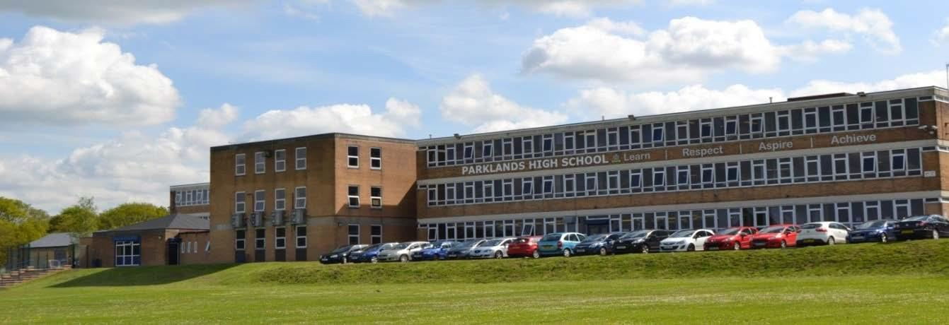

**Closing Date:** Wednesday 1st October 2025

**Proposed Interview Date:** Tuesday 7th October 2025

**PLEASE NOTE; We reserve the right to close this vacancy early, and interview early (before the final resignation date), for the right candidate.**

The application form can be downloaded from the vacancies page of the trust website https://aspirationalfutures.face-ed.co.uk/vacancies. In addition, please submit an accompanying statement to outline how your experiences demonstrate that you meet the person speciﬁcation. Please include here details of your experience and your suitability for the post—maximum 2 sides of A4, size 12 font.

For an informal discussion, please contact Karen Gray, Curriculum leader for Drama, either by telephone or email at kgray@parklandsacademy.co.uk Visits to the school are welcomed.

Parklands High School is committed to safeguarding and the process of safer recruitment. As a result, this post is subject to an enhanced Disclosure and Barring Service check, and all shortlisted candidates will be subject to online checks and expected to prove their identity at interview. The successful candidate will be expected to show original copies of qualiﬁcations and further proof of their identity.

| **Parklands High School** |
| --- |

| **Teacher of Drama, maternity cover:**  **Job Description and Person Specification** |
| --- |

| **Job Title** | Maternity cover - Teacher of Drama |
| --- | --- |
| **Department** | Drama |
| **Responsible to** | Curriculum Leader, SLT Line Manager, Headteacher |

| **Working time** | |
| --- | --- |
| 1. 190 days (or part time equivalent) of teaching a designated timetable plus 5 days (or equivalent) in which the teacher may only be required to perform other duties. 2. Any other session as directed by the Principal   **Prompt attendance and leadership/participation as appropriate in:**   1. Staff Briefings - 8.25am Mondays and Thursdays and any other designated meetings. 2. Agreed pre-school, break, lunchtime and post school duties   **Calendar:**   1. Full participation at directed time events on the annually published calendar. 2. Attendance at calendar sessions, meetings and INSET will be agreed at the start of the academic year. 3. Attendance at optional CPD opportunities. | |
| **Safeguarding** | To report all information and concerns to the Designated Senior Leader.  This should be completed promptly, factually, and in line with the school’s confidentiality requirements. |
| **Health and Safety** | To comply with the school’s Health and Safety Policy and report all information and concerns to the designated representative. This should be completed promptly. |

**Main duties:**

**1) Principal responsibilities:**

* To contribute to high quality teaching and learning in Drama including the production of shared resources.
* To participate in the development and implementation of appropriate syllabi, materials and schemes of work reflecting the school’s published aims, policies and procedures.
* To maintain accurate and complete assessment records and use them constructively to inform learning and to report to parents as required.
* To participate in the process of student target-setting, developing and implementing schemes of work and maintaining progressive learning outcomes in lessons.
* To attend and contribute to department meetings, TLC sessions and INSET training as required.
* To contribute to the Quality of Education in the Drama department.
* To participate in subject specific CPD opportunities that maximise the quality of Teaching and Learning in Drama.

**2) Additional specific responsibilities:**

* To be the form teacher of an assigned form.
* To undertake the pastoral care and guidance of each individual in the form and monitor their academic progress.
* To deal with and administer all routine business connected with the form, including returns as required.
* To take responsibility for the conduct of Form time.
* To provide or contribute to reports and keep records as appropriate.
* To check and comment on reports to parents as needed.
* To keep a general eye on the personal appearance and behaviour of the form and insist on a high standard.
* To attend and contribute to assemblies when required and actively supervise the form's movement both to the place of assembly and whilst it is in progress.
* To attend House meetings.

**3) General duties:**

* To have responsibility for safeguarding and promoting the welfare of the young people for whom you are responsible and all those you may come into contact with.
* To mark the register of all groups in accordance with the procedures determined by the attendance policies.
* To carry out a share of supervisory duties in accordance with published schedules.
* To share responsibility for good order and discipline in the school.
* To participate in appropriate meetings with colleagues and parents or carers.
* To participate in Appraisal and School Self Evaluation arrangements.
* To adhere to published school policies.
* To be courteous to colleagues, students and parents and provide a welcoming environment to guests.
* To discharge your duty of care for your own and others’ health and safety.

**4) Please note:**

* The above responsibilities are subject to the general duties and responsibilities contained in the "School Teachers' Pay and Conditions Document".
* This job description does not direct the particular amount of time to be spent on carrying out any of your duties and no part of it may be so construed.

Other duties will be required as and when necessary to the post from time to time. The job description is current at the date shown but, in conjunction with the postholder, may be revised by the Headteacher to reflect and anticipate changes in the job. These would be commensurate with the grade and job title. Such variations that are made to the duties and responsibilities will not change the general character of the post.

All aspects of the post will be evaluated by appropriate means including discussions with those staff the holder is responsible to, including the Headteacher and members of the SLT.

Please advise the school of any disability you may have or develop so that the school may endeavour to make any necessary reasonable adjustments to the job and the working environment.

**Person Specification – Teacher**

**Department – Drama**

|  | **Essential** | **Desirable** | **Method of assessment** |
| --- | --- | --- | --- |
| **QUALIFICATIONS** | | | |
| Qualified Teacher Status | ✔ |  | A/C |
| A recognised degree or equivalent | ✔ |  | A/C |
| **EXPERIENCE OF TEACHING** | | | |
| Successful Drama teaching to GCSE/KS4 level in an 11-16 school - either in placement or employment |  | ✔ | A/R |
| **PROFESSIONAL UNDERSTANDING** | | | |
| Assessment for Learning |  | ✔ | A/I/R |
| Planning |  | ✔ | A/I/R |
| Differentiation / personalisation, to include the needs of SEND students |  | ✔ | A/I/R |
| Behaviour management strategies |  | ✔ | A/I/R |
| ICT Literacy |  | ✔ | A/I/R |
| Awareness of the health and safety issues in teaching Drama |  | ✔ | A/I/R |
| **APPLICATION FORM AND LETTER** | | | |
| Letter should be clear, concise, accurately written and presented in an organised way | ✔ |  | A |
| Letter should outline a clear educational philosophy and relate directly to the requirements of the post and the school as outlined in the Job Description, this Person Specification and other documentation | ✔ |  | A |
| Application form should be fully completed, accurate and legible | ✔ |  | A |
| Candidates will have to demonstrate their suitability to work with children | ✔ |  | A/I/R |
| **KNOWLEDGE, SKILLS, AND ATTRIBUTES** | | | |
| Experience of quality assurance processes |  | ✔ | A/I/R |
| Excellent subject knowledge and effective classroom practice | ✔ |  | A/I/R |
| Knowledge and understanding of current educational issues, including national policies, priorities and legislation |  | ✔ | A/I/R |
| Knowledge and understanding of current curricular, teaching and learning issues relevant to the Drama department | ✔ |  | A/I/R |
| Understanding of strategies for school improvement |  | ✔ | A/I/R |
| Ability to use ICT to enhance learning and to administer professional duties | ✔ |  | A/I/R |
| Self-confidence, self-motivation, personal impact and presence | ✔ |  | A/I/R |
| The ability to relate well to students, parents and staff | ✔ |  | A/I/R |
| Effective communication and exceptional interpersonal skills | ✔ |  | A/I/R |
| High levels of commitment, enthusiasm and motivation | ✔ |  | A/I/R |
| A clear understanding of the needs, values and aspirations of all students being educated in this school | ✔ |  | A/I/R |
| A good sense of humour | ✔ |  | A/I |
| Willingness to make a substantial contribution to the school’s vision and future development | ✔ |  | A/I/R |

**Note**: We will always consider your references before confirming a job offer in writing.

**Key**:

A = Application (including letter)

C = Certificate

I = Interview

R = Reference